Pineline Poultry and Meats
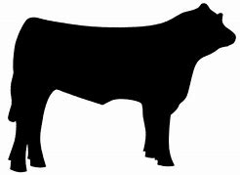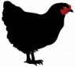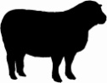
2026 Market Share Program

Welcome to the 2026 market season. The Marketshare we are offering , is a preseason buy in, minimum opening amount is $300.00. The market share will be printed on a hard copy card with the amount you have sent in plus 5%. It is simple to use, just bring with you when making a purchase and we will deduct the amount of your purchase from the card total. The advantage to buying in early is:
- An automatic 5% addition to your card
- The freedom to choose what you want and how much you want from what is currently available at our stand or farm
- Freedom to come whichever weeks work best for you
- First consideration for some of our limited meat products
WE offer Grass finished beef and lamb, Pastured Pork, Pastured Poultry, Pastured Rabbit and some free range Turkey. Our farming practices do not include the use of hormones, herbicides, pesticides or routine use of antibiotics. We feed local grains from Sniders, Martins Elevator and Farmers Coop. We are caring Farmers, Raising Healthy Meats from Happy Animals.

Please sign me up for the Market Share!
Name:_____________________________________
Address:___________________________________
Phone:_____________________________________
Email:_____________________________________
Market Share amount $_________. (min. $300.00)

Initial sign-up is limited, February through March 2026. Checks can be made to Pineline Poultry. We use Square as our credit card processor. If you wish to use a credit card, we pass along the merchant fee of 2.75% associated with the transaction. Our Venmo is @pinelinepoultry-Rachel Gagne. Zelle is 240-291-8254 Rachel Gagne
Choice of purchase locations or free delivery on Thursdays.(20 mile radius only- delivery fee to offset my time and gas beyond that).
Frederick City Farmers Market: 5/03/2026 through 11/22/2026. Sundays 9am till 1pm. 331 North Market Street , Frederick, Md 21701
Montgomery Village Farmers Market:6/06/2026 through 10/31/26.Saturdays 9-1. 9801 Centerway Rd. Montgomery Village Md.
Pineline Poultry and Meats (on the farm). Please call in advance, to make sure that we are home. 10707 Easterday Rd, Myersville, Md.21773-

Please clip top portion of form and send with payment to:
Pineline Poultry and Meats , 10707 Easterday Rd, Myersville, Md. 21773 phone 240-291-8254 (Rachel)

